
Franconia United Methodist Church believes that everyone is a child of God.
We welcome all people to worship, join in membership, serve in lay leadership,
and actively participate in the life of the church.
We welcome and affirm all persons without regard to gender, gender identity, race,
sexual orientation, faith tradition, age, marital status, family structure,
economic background, political affiliation, physical or mental ability or life experience.
We commit to extend Christ’s hospitality, creating a place of safety and sanctuary for all people.
We recognize there are differences among us and although we may not think or look alike,
we commit to respect and love one another as we are all the family of God.
We further commit ourselves to loving acts of invitation, hospitality, and community,
providing ministry to, for, and with all persons without exception,
fostering a sense of belonging where people are respected and valued as beloved children of God.

Media Tech Team: Small Ensemble:
Bobby Anderson Karen Ingle
Joana Arthur Amy McCarthy
Zach Chambers Robert Shuffett
Caroline Coltrin
Andrew Hamilton
Leah Hamilton
Jess Posey
Henry McCarthy
Grace Stahl
Liam Upp
Staff:
Reverend: Melissa Porter-Miller pastormelissa@franconiaumc.org
Church Office: Rose Munson churchoffice@franconiaumc.org
Children’s Ministry: Kim Cimino childrensministry@franconiaumc.org
Music Ministry: Amy McCarthy music@franconiaumc.org
Praise & Worship Leader: Sarah Chambers praise@franconiaumc.org
Youth & Young Adult Ministries: Sarah Chambers youth@franconiaumc.org
Organist: June Shuffett organist@franconiaumc.org
Handbells: Linda Biscardo handbells@franconiaumc.org
All God’s Children Preschool: Jessica Copes AGCpreschool@franconiaumc.org
Nursery: Susann Ferrell


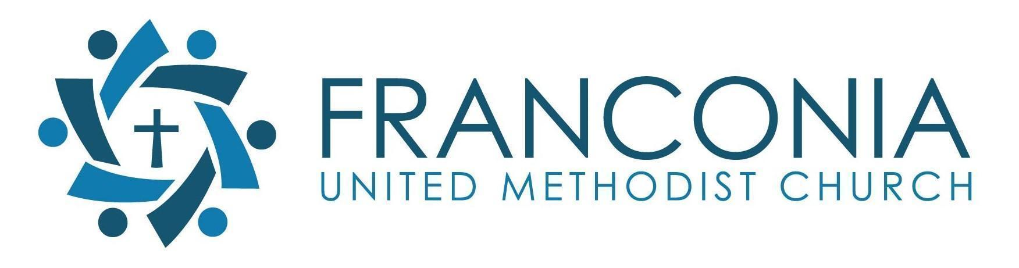

6037 Franconia Rd. Alexandria, VA 22310 | 703-971-5151 | www.franconiaumc.org

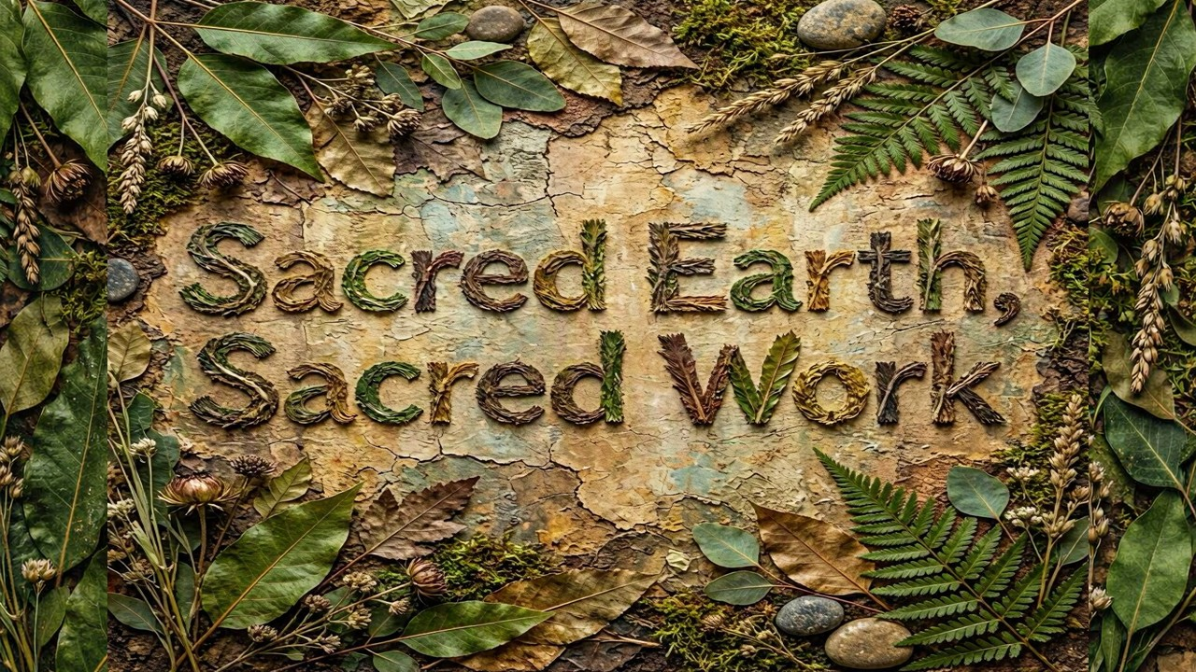

August 2, 2026 at 10:00 AM – Traditional Service
Worship Series: Sacred Earth, Sacred Work
Message: Glorious Diversity

Traditional Order of Worship
August 2, 2026
Worship Series: Sacred Earth, Sacred Work

Prelude Holy, Holy, Holy June Shuffett

Welcome/Announcements Rev. Melissa Porter-Miller

*Call to Worship – Celebrating God’s Diverse Family

Pastor: God is good!
People: All the time!
Pastor: And all the time!
People: God is good!

Pastor: Indeed, we gather to celebrate the goodness of God
and the beauty of God’s diverse creation.
People: We come from different stories, different experiences,
and different walks of life, yet we are one in God’s love.
Pastor: No matter our background, our doubts, or our abilities,
God welcomes us into this sacred space.
People: We come just as we are, embraced by grace
and claimed as God’s beloved children.
Pastor: God gathers us as a mosaic of humanity,
each person reflecting the image of the Creator.
People: Together we celebrate the gifts, voices,
and perspectives that strengthen the Body of Christ.
Pastor: Let us draw the circle wide, making room
or every heart, every mind, and every soul.
People: We open ourselves to God and to one another,
that all may know they belong.
Pastor: Now, as the Light of Christ comes among us, you are invited to turn and
face the light. As we turn toward Christ, may our hearts turn toward God,
toward one another, and toward a world longing for welcome and hope.
People: Christ our Light, lead us in the way of love and inclusion,
that through our diversity we may reflect Your glory,
and all may know they are beloved. AMEN.

*Hymn Many Gifts, One Spirit UMH#114

*Opening Prayer Rev. Melissa Porter-Miller

Pastor: Let us pray
People: Gracious God, Creator of all.
We thank You for the beauty and diversity of Your creation
and for the many gifts, abilities, perspectives, and experiences
You have woven into the body of Christ.
Where we lack understanding, grant us wisdom.
Where we hold assumptions, grant us humility.
Where barriers divide us, grant us the courage
to create communities of welcome, belonging,
and participation for all Your children.
Help each person to know they are loved, valued, and created in Your image.
Through Jesus Christ our Lord. AMEN.

Children’s Moment Kim Cimino

Litany for Disability Awareness Sunday Rev. Melissa Porter-Miller

Leader (Jordan): God created all living things. God created humans in God’s
image, and God said that creation was good!
People: So, we to believe that people of all abilities and ways of thinking are
created in the image of God.
Leader (Pat): God called leaders like Jacob and Moses, whose bodies and speech
were imperfect, to lead God’s people!
People: So, we too welcome leaders with a variety of abilities and diverse
ways of thinking, learning, and communicating.
Leaders (Leah): The Psalms proclaim that we are fearfully and wonderfully made,
and loved by God.
People: So, we too celebrate every person as a unique and beloved gift from God.
Leader (Jordan): Jesus welcomed those who were excluded or misunderstood and
made them part of the community!
People: So, we too, commit ourselves to congregations where all people are
fully welcomed and valued.
Leader (Pat): Paul taught that the Church needs people of all gifts and abilities to
be the Body of Christ!
People: So, we too honor the gifts each person brings, knowing every mind
and every person has something sacred to share.

Leader (Leah): Only God is perfect!

People: We are all human, called not to perfection, but to love, justice, and
belonging as followers of Jesus who bring hope to all people. AMEN.

Prayers of the People Sarah Chambers

Offering Song Draw the Circle Wide Small Ensemble

Doxology UMH #95

Praise God from Whom all Blessings flow!
Praise Him all creatures here below!
Praise Him above ye heavenly hosts!
Praise Father, Son and Holy Ghost! AMEN

*Prayer of Thanksgiving Rev. Melissa Porter-Miller

Old Testament Reading Genesis 11: 1-9 Jordan Biscardo

Reader: All people on the earth had one language and the same words. When they
traveled east, they found a valley in the land of Shinar and settled there. They said
to each other,

People: “Come, let’s make bricks and bake them hard.” They used bricks for
stones and asphalt for mortar. They said, “Come, let’s build for ourselves a
city and a tower with its top in the sky, and let’s make a name for ourselves so
that we won’t be dispersed over all the earth.”

Reader: Then the Lord came down to see the city and the tower that the humans
built. And the Lord said, “There is now one people and they all have one language.
This is what they have begun to do, and now all that they plan to do will be
possible for them. Come, let’s go down and mix up their language there so they
won’t understand each other’s language.”

People: So, the Lord scattered them abroad from there over the face of all the
earth, and they left off building the city.

Reader: Therefore, it was called Babel,
People: because there the Lord mixed up the language of all the earth; and
from there the Lord dispersed them over all the earth.

Message Glorious Diversity Peggy Owusu-Ansah

Invitation to Communion Sarah Chambers

Prayer of Confession

Gracious and loving God,
You created every person in Your image
and declared all creation good.
Yet we confess that we have not always celebrated
the diversity of Your people.
We have made assumptions about others
instead of seeking understanding.
We have excluded when we should have welcomed.
We have judged when we should have listened.
We have overlooked the gifts of some
while elevating the voices of others.
Forgive us for the ways we have built barriers
instead of bridges,
and for the times we have failed to recognize
Christ in those who are different from us.
Open our hearts to Your Spirit.
Teach us humility where we are proud,
compassion where we are fearful,
and courage where change is needed.
Create in us a community where every person
is valued, respected, and loved,
and where all may know they belong;
through Jesus Christ our Lord. AMEN

Assurance and Pardon

Leader: Hear the Good News: God does not abandon us in our brokenness.
Through Jesus Christ, God has shown us a love that crosses every barrier, heals
every division, and makes us one family.:
In the name of Jesus Christ, you are forgiven.

People: In the name of Jesus Christ, you are forgiven!
All: Glory to God. AMEN.

The Great Thanksgiving Rev. Melissa Porter-Miller

The Lord be with you.
And also with you.
Lift up your hearts.
We lift them up to the Lord.
Let us give thanks to the Lord our God.
It is right to give our thanks and praise.

It is right, and a good and joyful thing . . .
And so, we Your people on earth
and with all the company of heaven
praise Your name and join their unending hymn:
Holy, holy, holy Lord, God of power and might,
heaven and earth are full of Your glory.
Hosanna in the highest.
Blessed is he who comes
in the name of the Lord.
Hosanna in the highest.

Holy are You . . .And so, in remembrance
of these Your mighty acts in Jesus Christ,
we offer ourselves in praise and thanksgiving
as a holy and living sacrifice,
in union with Christ’s offering for us,
as we proclaim the mystery of faith.
Christ has died, Christ is risen, Christ will come again.

The Lord’s Prayer
Our Father, who art in heaven, hallowed be Thy name,
Thy kingdom come, Thy will be done,
On earth as it is in heaven.
Give us this day our daily bread
And forgive us our trespasses
as we forgive those who trespass against us.
And lead us not into temptation,
But deliver us from evil.
For Thine is the kingdom,
and the power and the glory. Forever. AMEN.

Breaking of the Bread

Giving the Bread and Cup

Music During Communion One Bread, One Body UMH #620

Prayer Following Communion
Eternal God,
we give You thanks for this holy mystery
in which You have given Yourself to us.
Grant that we may go into the world
in the strength of Your Spirit,
to give ourselves to others
in the name of Jesus Christ our Lord. AMEN.

*Hymn Help Us Accept Each Other UMH #560

*Benediction Rev. Melissa Porter-Miller

Postlude Leaning on the Everlasting Arms June Shuffett

